***USE CASE 001 – SIGN IN***

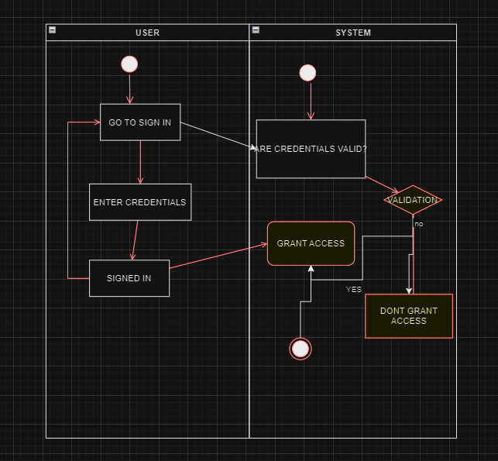

***USE CASE 002 – SIGN UP USING DL/ID***

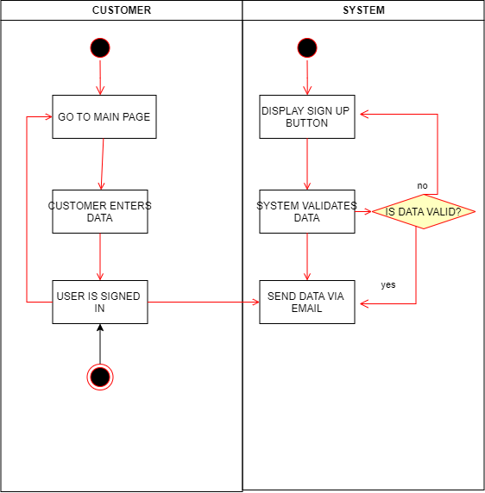

***USE CASE 003 – VIEW RESERVATIONS***

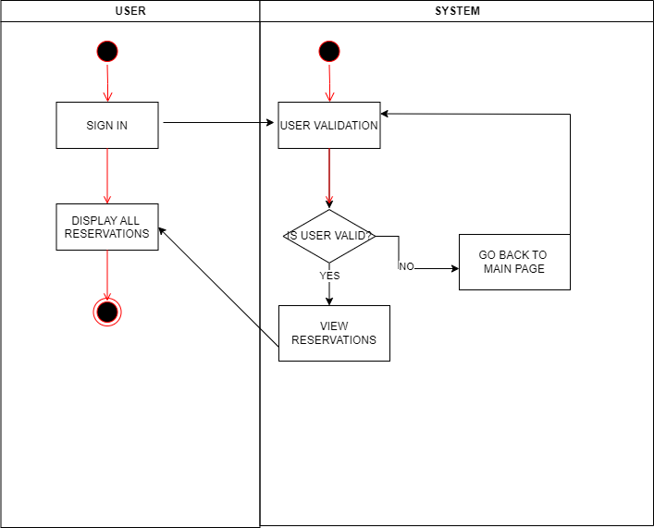

***USE CASE 004 – REPORT WHEN A CAR IS RETURNED***

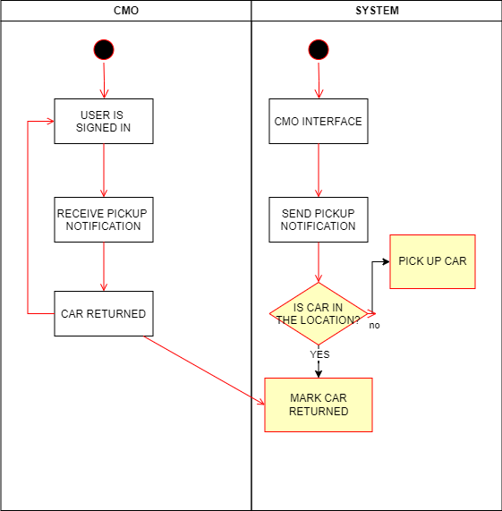

***USE CASE 005 – REPORT DAMAGES OR FINES***

